Wilson Trading Center is retail center which facilitate buy goods up to 10 costumers from the shop. Every customer gets 5 possibilities to buy goods. Purchase of goods must be purchased according to the “Table 1”. Customers also get discounts to billing amount.

Table 1

|  |  |  |  |
| --- | --- | --- | --- |
| Item Code | Item Name | Item Quantity | Item Price(Rs.) |
| 01 | Rice | 90(Kg) | 105(1Kg) |
| 02 | Salmon Tin | 50 | 275 |
| 03 | sugar | 60(Kg) | 120(1Kg) |
| 04 | Soap | 70 | 60 |
| 05 | Cheese | 80 | 340 |

Table 2

|  |  |
| --- | --- |
| Price(Rs.) | Discount |
| Price >= 8000 | 15% |
| Price >= 5000 | 10% |
| Price < 5000 | 2% |

1. After Purchasing of goods by the customer, an Invoice must be produced according to the items he/she purchased, and it should be displayed.
2. Table 1 should be updated after purchasing of goods from customer to customer and it should be displayed.
3. After 10 customers made their purchases from the retail center program will end. At the end of the program it should display the remaining inventory and income from the sales.

By considering the above information write a C program. When executing the program if user inputs wrong data, it should display a error message.

C Program

#include <stdio.h>

int main (void)

{

//assign the variable

int count1 = 1 ;

float net_A_total = 0 ;

int rice_quantity = 90 ,rice_price =105;

int salmon_quantity = 50 ,salmon_price =275;

int sugar_quantity = 60 ,sugar_price =120;

int soap_quantity = 70 ,soap_price =60;

int cheese_quantity = 80 ,cheese_price =340;

while(count1<=10)// 1st loop start

{

//assign the variable

int count2 = 1 ;

int Item_code;

float Item_quantity = 0 , total =0 , total1 = 0 , total2 = 0 , total3 = 0 , total4 = 0 , total5 = 0 , discount = 0 , amount = 0 ;

char type, ch = 'Y';

int rice_qty = 0 , salmon_qty = 0 , sugar_qty = 0 , soap_qty = 0 , cheese_qty = 0 ;

//print the Table of items

printf(" ------------------------------------\n");

printf(" WILSON TRAD CEMTER\n" );

printf(" ------------------------------------\n\n");

printf("-------------------------------------------------------\n");

printf(" Item_Code | Item_Name | Item_Quantity | Item_Price(Rs.) \n" );

printf("-------------------------------------------------------\n");

printf(" 01 | Rice | %dKg | %d(1Kg)\n" , rice_quantity , rice_price );

printf(" 02 | Salmon tin | %d | %d\n" , salmon_quantity , salmon_price );

printf(" 03 | Sugar | %dKg | %d(1Kg)\n" , sugar_quantity , sugar_price );

printf(" 04 | Soap | %d | %d\n" , soap_quantity , soap_price );

printf(" 05 | Cheese | %d | %d\n\n" , cheese_quantity , cheese_price );

while(count2<=5)//2nd loop start

{

printf("Enter the Item Code:");//prompt for input

scanf("%d" , &Item_code);//read item_code from user

printf("Enter the Item Quantity:");//prompt for input

scanf("%f" , &Item_quantity);//read item_quantity from user

printf("\n");

if( Item_code==01 )//check the item code

{

if( Item_quantity < rice_quantity )//check the item quantity

{

total1 = Item_quantity * rice_price ;//calculate item 1 total

total = total + total1 ;//calculate full total

rice_quantity = rice_quantity - Item_quantity ;//calculate left items

rice_qty = Item_quantity ;//provide new values

count2++;

}

else

{

printf("------------------------------------------------------\n");

printf("You can't get this item please check the Item Quantity\n");//print the error message

printf("------------------------------------------------------\n\n");

}

}

else

{

if( Item_code==02 )//check the item code

{

if( Item_quantity < salmon_quantity )//check the item quantity

{

total2 = Item_quantity * salmon_price ;//calculate item 2 total

total = total + total2 ;//calculate full total

salmon_quantity = salmon_quantity - Item_quantity ;//calculate left items

salmon_qty = Item_quantity ;//provide new values

count2++;

}

else

{

printf("------------------------------------------------------\n");

printf("You can't get this item please check the Item Quantity\n");//print the error message

printf("------------------------------------------------------\n\n");

}

}

else

{

if( Item_code==03 )//check the item code

{

if( Item_quantity < sugar_quantity )//check the item quantity

{

total3 = Item_quantity * sugar_price ;//calculate item 3 total

total = total + total3 ;//calculate full total

sugar_quantity = sugar_quantity - Item_quantity ;//calculate left items

sugar_qty = Item_quantity ;//provide new values

count2++;

}

else

{

printf("------------------------------------------------------\n");

printf("You can't get this item please check the Item Quantity\n");//print the error message

printf("------------------------------------------------------\n\n");

}

}

else

{

if( Item_code==04 )//check the item code

{

if( Item_quantity < soap_quantity )//check the item quantity

{

total4 = Item_quantity * soap_price ;//calculate item 4 total

total = total + total4 ;//calculate full total

soap_quantity = soap_quantity - Item_quantity ;//calculate left items

soap_qty = Item_quantity ;//provide new values

count2++;

}

else

{

printf("------------------------------------------------------\n");

printf("You can't get this item please check the Item Quantity\n");//print the error message

printf("------------------------------------------------------\n\n");

}

}

else

{

if( Item_code==05 )//check the item code

{

if( Item_quantity < cheese_quantity )//check the item quantity

{

total5 = Item_quantity * cheese_price ;//calculate item 5 total

total = total + total5 ;//calculate full total

cheese_quantity = cheese_quantity - Item_quantity ;//calculate left items

cheese_qty = Item_quantity ;//provide new values

count2++;

}

else

{

printf("------------------------------------------------------\n");

printf("You can't get this item please check the Item Quantity\n");//print the error message

printf("------------------------------------------------------\n\n");

}

}

else

{

printf("----------------------------------------------\n");

printf(" ITEM CODE IS INCORRECT!!!\n"); //print the error message

printf("----------------------------------------------\n\n");

}

}

}

}

}

}//2nd loop stop

if( total >= 8000 )

{

discount = total * 15/100 ;//calculate discount

printf("Your NET AMOUNT(Rs.) :%f\n" , (total - discount) );//print the net amount from customer's

printf("Enter the AMOUNT YOU PAY(Rs.):");//prompt for input

scanf("%f" , &amount );//read amount from user

}

else

{

if( total >= 5000 )

{

discount = total * 10/100 ;//calculate discount

printf("Your NET AMOUNT(Rs.) :%f\n" , (total - discount) );//print the net amount from customer's

printf("Enter the AMOUNT YOU PAY(Rs.):");//prompt for input

scanf("%f" , &amount );//read amount from user

}

else

{

discount = total * 2/100 ;//calculate discount

printf("Your NET AMOUNT(Rs.) :%f\n" , (total - discount) );//print the net amount from customer's

printf("Enter the AMOUNT YOU PAY(Rs.):");//prompt for input

scanf("%f" , &amount );//read amount from user

printf("\n\n");

}

}

//print the Customer's Bill

printf("------------------------------------------------\n");

printf(" INVOICE \n");

printf("------------------------------------------------\n");

printf(" ITEM QTY PRICE AMOUNT(Rs.) \n");

printf("------------------------------------------------\n");

printf(" Rice %dKg %d(1Kg) %f\n" , rice_qty , rice_price , total1 );

printf(" Salmon tin %d %d %f\n" , salmon_qty , salmon_price , total2 );

printf(" Sugar %dKg %d(1Kg) %f\n" , sugar_qty , sugar_price , total3 );

printf(" Soap %d %d %f\n" , soap_qty , soap_price , total4 );

printf(" Cheese %d %d %f\n" , cheese_qty , cheese_price , total5 );

printf("------------------------------------------------\n");

printf(" FULL AMOUNT %f\n" , total );

printf(" DISCOUNT -%f\n" , discount );

printf(" -----------\n");

printf(" NET AMOUNT %f\n" , (total - discount) );

printf("------------------------------------------------\n");

printf(" CASH %f\n" , amount );

printf("CASH BALANCE %f\n" , amount - (total - discount) );

printf("------------------------------------------------\n");

printf(" THANK YOU \n" );

printf("------------------------------------------------\n\n");

net_A_total = net_A_total + (total - discount) ; //calculate net amount total

count1++;

}1st loop stop

//print the item left in shop

printf("------------------------------------------------\n");

printf(" WE HAVE STOPPED DELIVERING GOODS TODAY\n" );

printf("------------------------------------------------\n");

printf(" --The number of items left--\n");

printf("------------------------------------------\n");

printf(" Item_Code | Item_Name | Item_Quantity |\n" );

printf("------------------------------------------\n");

printf(" 01 | Rice | %dKg |\n" , rice_quantity );

printf(" 02 | Salmon tin | %d |\n" , salmon_quantity );

printf(" 03 | Sugar | %dKg |\n" , sugar_quantity );

printf(" 04 | Soap | %d |\n" , soap_quantity );

printf(" 05 | Cheese | %d |\n\n", cheese_quantity );

printf("THE AMOUNT RECEIVED TODAY:%f\n\n" , net_A_total); //print the received amount

return 0;

}

Test case1: When someone buys goods

------------------------------------

WILSON TRAD CEMTER

------------------------------------

---------------------------------------------------------------------------

Item_Code | Item_Name | Item_Quantity | Item_Price(Rs.)

---------------------------------------------------------------------------

01 | Rice | 90Kg | 105(1Kg)

02 | Salmon tin | 50 | 275

03 | Sugar | 60Kg | 120(1Kg)

04 | Soap | 70 | 60

05 | Cheese | 40 | 340

Enter the Item Code:01

Enter the Item Quantity:10

Enter the Item Code:02

Enter the Item Quantity:10

Enter the Item Code:03

Enter the Item Quantity:20

Enter the Item Code:04

Enter the Item Quantity:25

Enter the Item Code:05

Enter the Item Quantity:10

Your NET AMOUNT (Rs.):9435.000000

Enter the AMOUNT YOU PAY(Rs.):10000

-------------------------------------------------------------

INVOICE

-------------------------------------------------------------

ITEM QTY PRICE AMOUNT(Rs.)

--------------------------------------------------------------

Rice 10Kg 105(1Kg) 1050.000000

Salmon tin 10 275 2750.000000

Sugar 20Kg 120(1Kg) 2400.000000

Soap 25 60 1500.000000

Cheese 10 340 3400.000000

---------------------------------------------------------------

FULL AMOUNT 11100.000000

DISCOUNT -1665.000000

--------------------

NET AMOUNT 9435.000000

----------------------------------------------------------------

CASH 10000.000000

CASH BALANCE 565.000000

------------------------------------------------

THANK YOU

------------------------------------------------

(This is updated table for next customer)

------------------------------------

WILSON TRADCEMTER

------------------------------------

-------------------------------------------------------

Item_Code | Item_Name | Item_Quantity | Item_Price(Rs.)

-------------------------------------------------------

01 | Rice | 80Kg | 105(1Kg)

02 | Salmon tin | 40 | 275

03 | Sugar | 40Kg | 120(1Kg)

04 | Soap | 45 | 60

05 | Cheese | 30 | 340

Enter the Item Code:

Test case2: When user input wrong **ITEM CODE & TOO MANY GOODS**  then program will display error message

------------------------------------

WILSON TRAD CEMTER

------------------------------------

---------------------------------------------------------------------------

Item_Code | Item_Name | Item_Quantity | Item_Price(Rs.)

---------------------------------------------------------------------------

01 | Rice | 90Kg | 105(1Kg)

02 | Salmon tin | 50 | 275

03 | Sugar | 60Kg | 120(1Kg)

04 | Soap | 70 | 60

05 | Cheese | 40 | 340

Enter the Item Code:12

Enter the Item Quantity:10

----------------------------------------------

ITEM CODE IS INCORRECT!!!

----------------------------------------------

Enter the Item Code:01

Enter the Item Quantity:100

-----------------------------------------------------------------------

You can't get this item please check the Item Quantity

------------------------------------------------------------------------

Enter the Item Code:

Test case3: Once everyone has purchased the goods

---------------------------------------------------------------------

WE HAVE STOPPED DELIVERING GOODS TODAY

---------------------------------------------------------------------

--The number of items left--

------------------------------------------------------------

Item_Code | Item_Name | Item_Quantity |

------------------------------------------------------------

01 | Rice | XKg |

02 | Salmon tin | X |

03 | Sugar | XKg |

04 | Soap | X |

05 | Cheese | X |

THE AMOUNT RECEIVED TODAY(Rs.):xxxxxx.xxx

Test case1

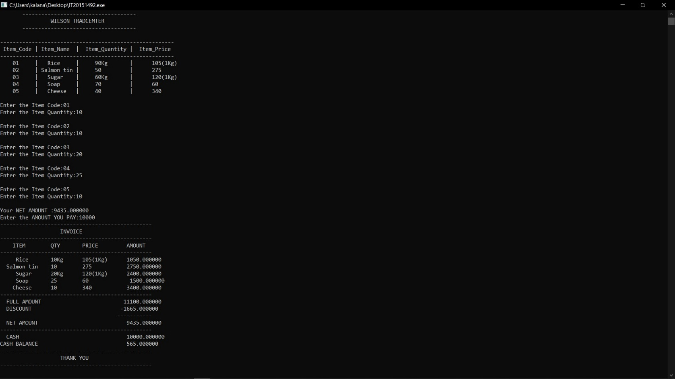

Test case2

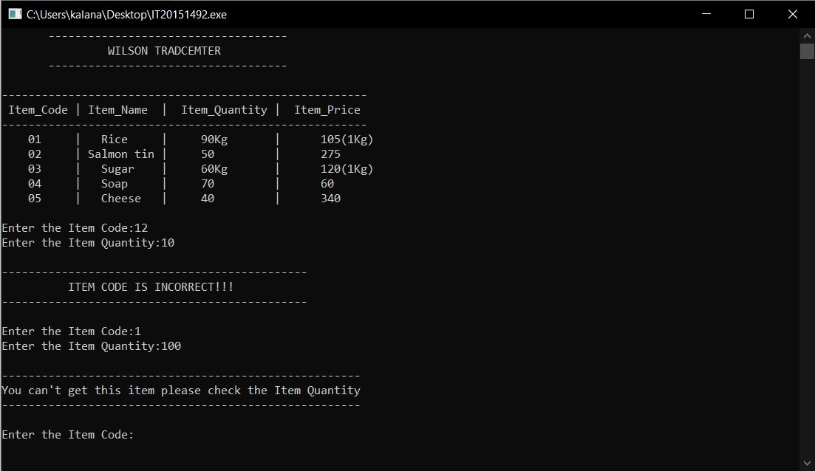

Test case3

